Rozgar awareness camp: Rozgar awareness camp was organized on 9-3-23 in which information regarding different schemes of the Government were given to the cadets.
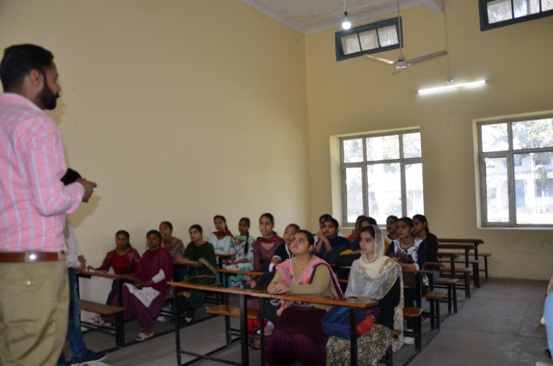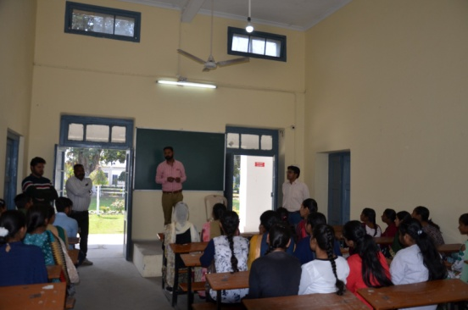

Seminar on agniveer: Seminar on agniveer was organised on 13-3-23 in which Col Jai Veer Singh, ARO, JHld Cantt came to aware the students regarding Agniveer Scheme of the government.
